Donation saved my life. Was it yours?

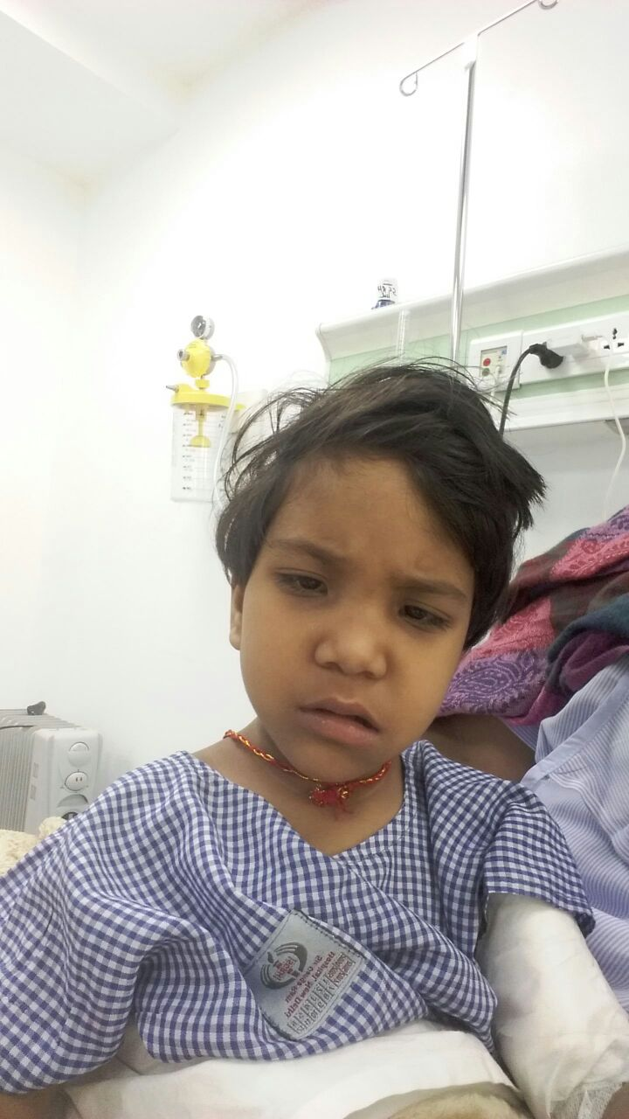
It is our pleasure to inform you that Ravya’s bone marrow has been successfully transplanted in Shri Gangaram Hospital because of your generous donation. We are also very proud to tell you that your donation was part of Rs.20lac that helped Ravya survive.
Earlier, Ravya was very sick and was frequently vomiting. Her father Omkar Prasad took her to a hospital in Ahmadabad. He then came to know that her daughter needs immediate bone marrow transplantation. Since those services were not available in Ahmadabad Mr. Omkar brought Ravya to Shri Gangaram Hospital, Delhi.
Due to lack of funds, Mr. Omkar contacted us. We started to put our hearts and souls, the moment we heard, because like you, we also could not bear Mr. Omkar’s helplessness and wanted to help him.
Your donation helped bring Ravya back from the mouth of death. Ravya’s blood platelet count has reached above 150,000 from just 6000 and blood hemoglobin has reached above 12.5 gpd from just 3.1 gpd. Had you and many other people like you, not helped her, she probably would not have made it.
Once again we would like to thank you for your great work and we hope you continue helping people like Mr. Omkar and Kids like Ravya.
‘We rise by lifting others’
